Question : 1
Use plt.subplots() to create a 2x2 grid of subplots and plot four different types of charts (line, bar, scatter, and pie) using any sample data of your choice :

import matplotlib.pyplot as plt
days =["Mon","Tue","Wed","Thu","Fri"]
sales =[20,35,30,45,50]

products =["A","B","C","D"]
quantity =[25,40,30,20]

age =[18,20,22,24,26]
marks =[55,65,70,80,90]

expenses =[30,25,20,15,10]
categories = ["Food","Travel","Shopping","Bills","Other"]

fig, ax=plt.subplots(2, 2, figsize=(12,8))

# Line chart
ax[0, 0].plot(days,sales,marker="o")
ax[0, 0].set_title("Daily Sales")
ax[0, 0].set_xlabel("Day")
ax[0, 0].set_ylabel("Sales")
# Bar chart
ax[0, 1].bar(products,quantity)
ax[0, 1].set_title("Product Quantity")
ax[0, 1].set_xlabel("Product")
ax[0, 1].set_ylabel("Quantity")
# Scatter plot
ax[1, 0].scatter(age,marks)
ax[1, 0].set_title("Age vs Marks")
ax[1, 0].set_xlabel("Age")
ax[1, 0].set_ylabel("Marks")
# Pie chart
ax[1, 1].pie(expenses,labels=categories,autopct="%1.1f%%")
ax[1, 1].set_title("Monthly Expenses")
plt.tight_layout()
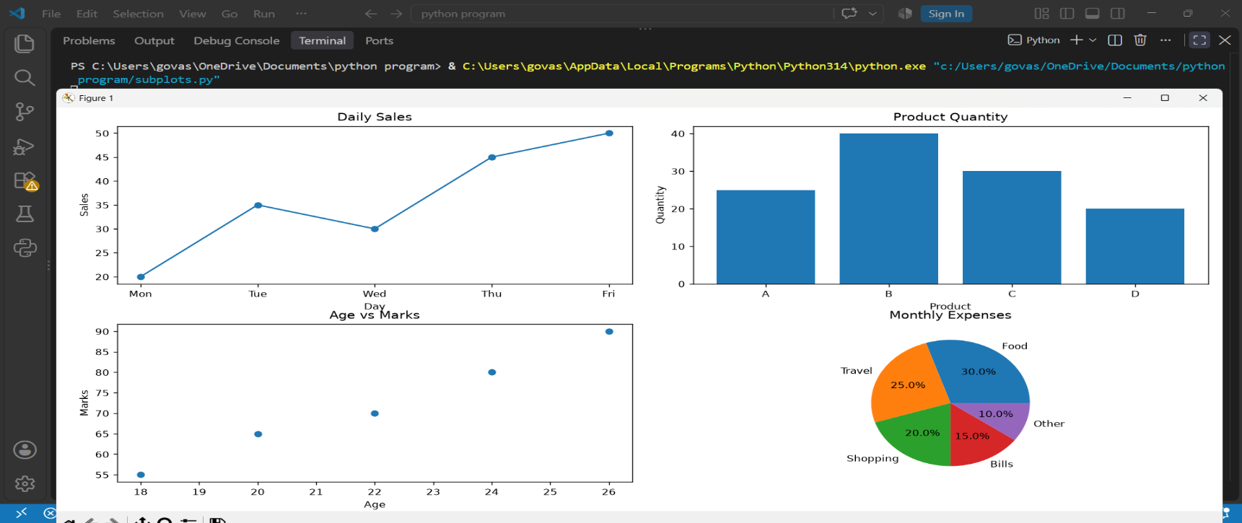
plt.show()
Question : 2
Plot a comparison of average delivery times for Zomato, Swiggy, and Domino's using a bar chart, and style each bar with a different color, linestyle, and linewidth using Matplotlib plot styling options :

import matplotlib.pyplot as plt
companies =["Zomato","Swiggy","Domino's"]
delivery_time = [35,30,25]

colors =["red","orange","blue"]
linestyles =["-","--",":"]
linewidths =[3,4,5]

plt.figure(figsize=(8, 5))

bars = plt.bar(companies,delivery_time,color=colors,edgecolor="black",linewidth=2)
for bar, linestyle, linewidth in zip(bars,linestyles,linewidths):
bar.set_linestyle(linestyle)
bar.set_linewidth(linewidth)
plt.title("Average Delivery Time")
plt.xlabel("Company")
plt.ylabel("Delivery Time (minutes)")
plt.show()

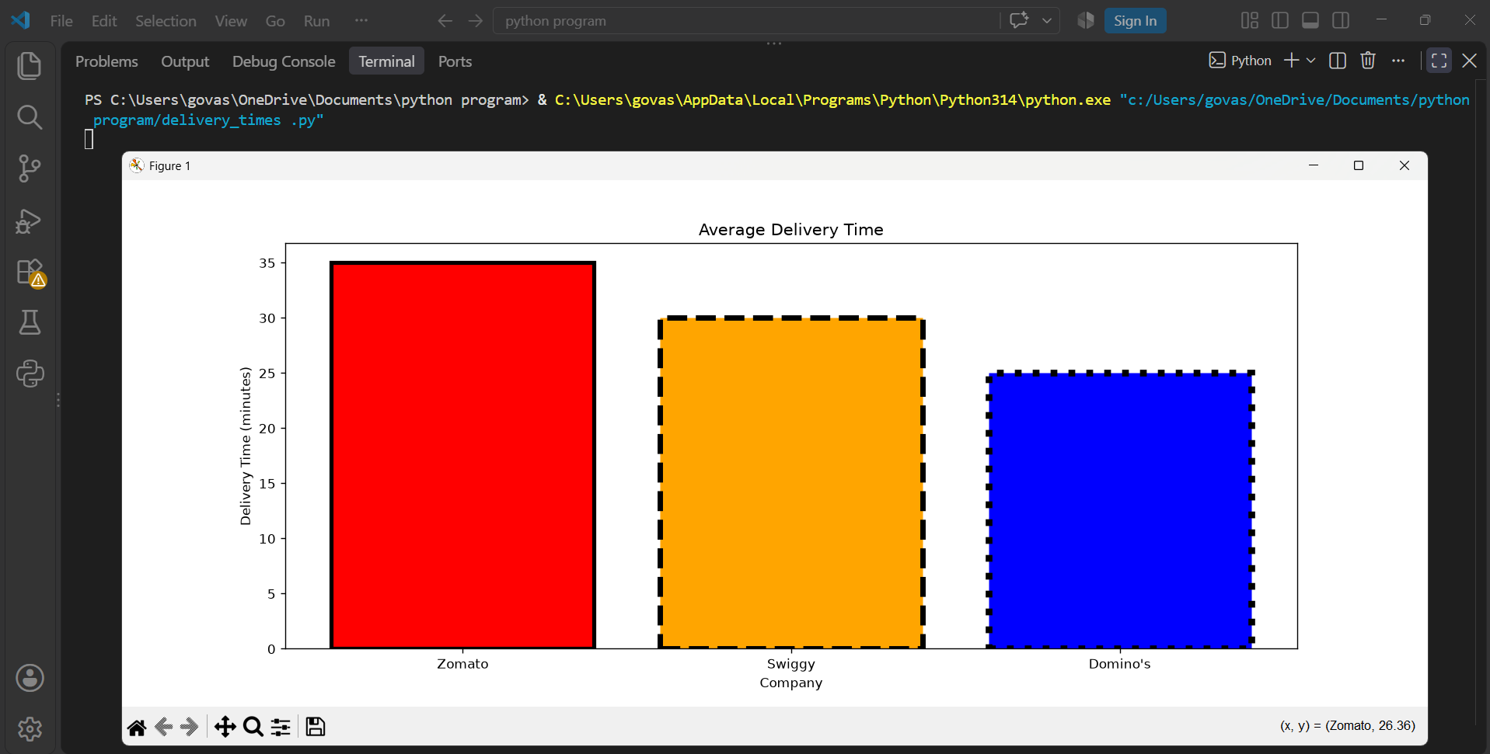

Question : 3
Create a multi-axis chart that shows the number of Instagram followers (left y-axis) and average daily posts (right y-axis) for five influencers. Use different colors and markers for each axis :

import matplotlib.pyplot as plt
influencers =["Influencer A","Influencer B","Influencer C","Influencer D","Influencer E"]
followers =[120000,250000,180000,320000,400000]
daily_posts =[2,4,3,5,6]

fig, ax1 = plt.subplots(figsize=(10, 6))
# Left Y-axis - Instagram Followers
ax1.plot(
influencers, followers, color="blue", marker="o", linewidth=2, label="Followers")
ax1.set_xlabel("Influencers")
ax1.set_ylabel("Instagram Followers",color="blue")
ax1.tick_params(axis="y",labelcolor="blue")
# Right Y-axis - Average Daily Posts
ax2 = ax1.twinx()
ax2.plot( influencers,
daily_posts,
color="red",
marker="s",
linewidth=2,
label="Daily Posts"
)

ax2.set_ylabel("Average Daily Posts",color="red")
ax2.tick_params(axis="y",labelcolor="red")

plt.title("Instagram Followers vs Average Daily Posts")
plt.xticks(rotation=20)

plt.tight_layout()
plt.show()
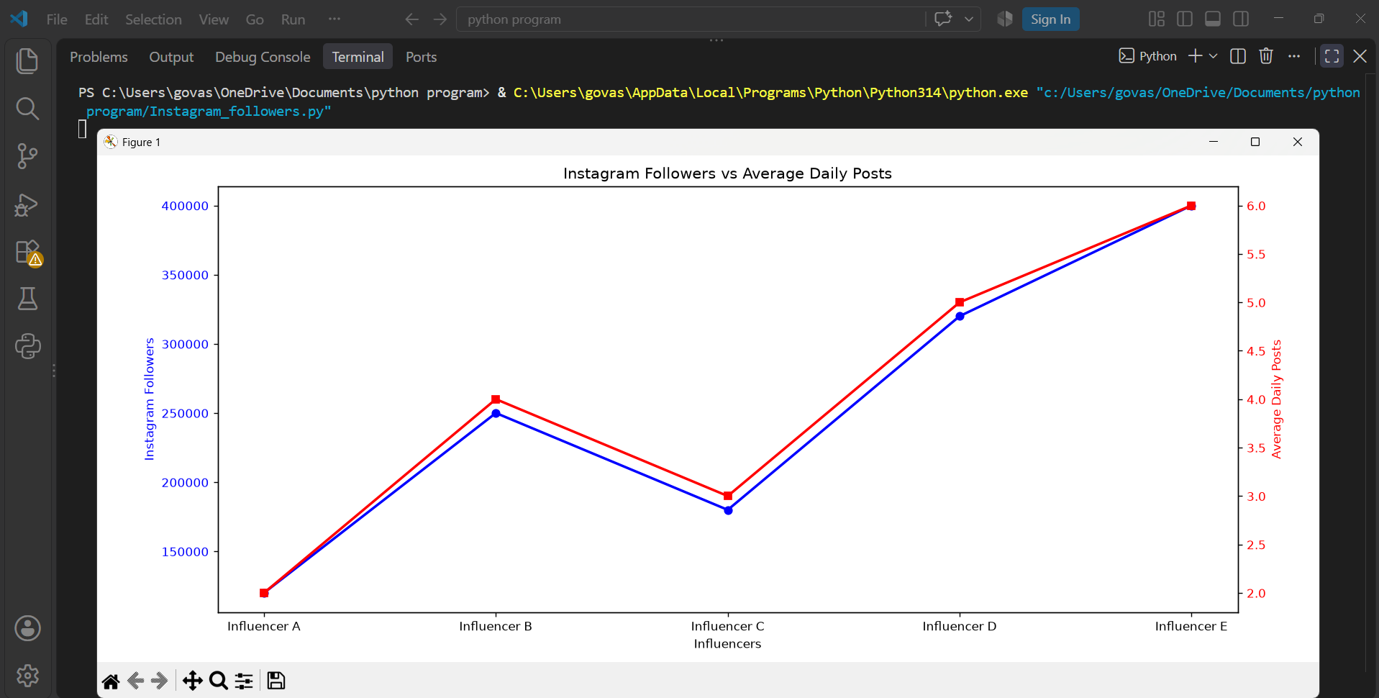

Question : 4
Plot the number of tickets sold for five recent Bollywood movies (categorical) versus their IMDB ratings (numeric) using a scatter plot. Add annotations to display the movie names above each point :

import matplotlib.pyplot as plt
movies = ["Jawan","Pathaan","Animal","Stree 2","Chhaava"]
tickets_sold =[120,105,115,95,100]
imdb_rating =[6.9,5.9,6.1,7.0,8.0]
plt.figure(figsize=(9, 6))
plt.scatter(
tickets_sold, imdb_rating, s=100, marker="o")
for movie, tickets, rating in zip(
movies, tickets_sold, imdb_rating ):
plt.annotate(
movie, (tickets, rating), xytext=(5, 8), textcoords="offset points" )
plt.title("Bollywood Movies: Tickets Sold vs IMDb Rating")
plt.xlabel("Tickets Sold (Millions)")
plt.ylabel("IMDb Rating")
plt.grid(True, linestyle="--",alpha=0.5)
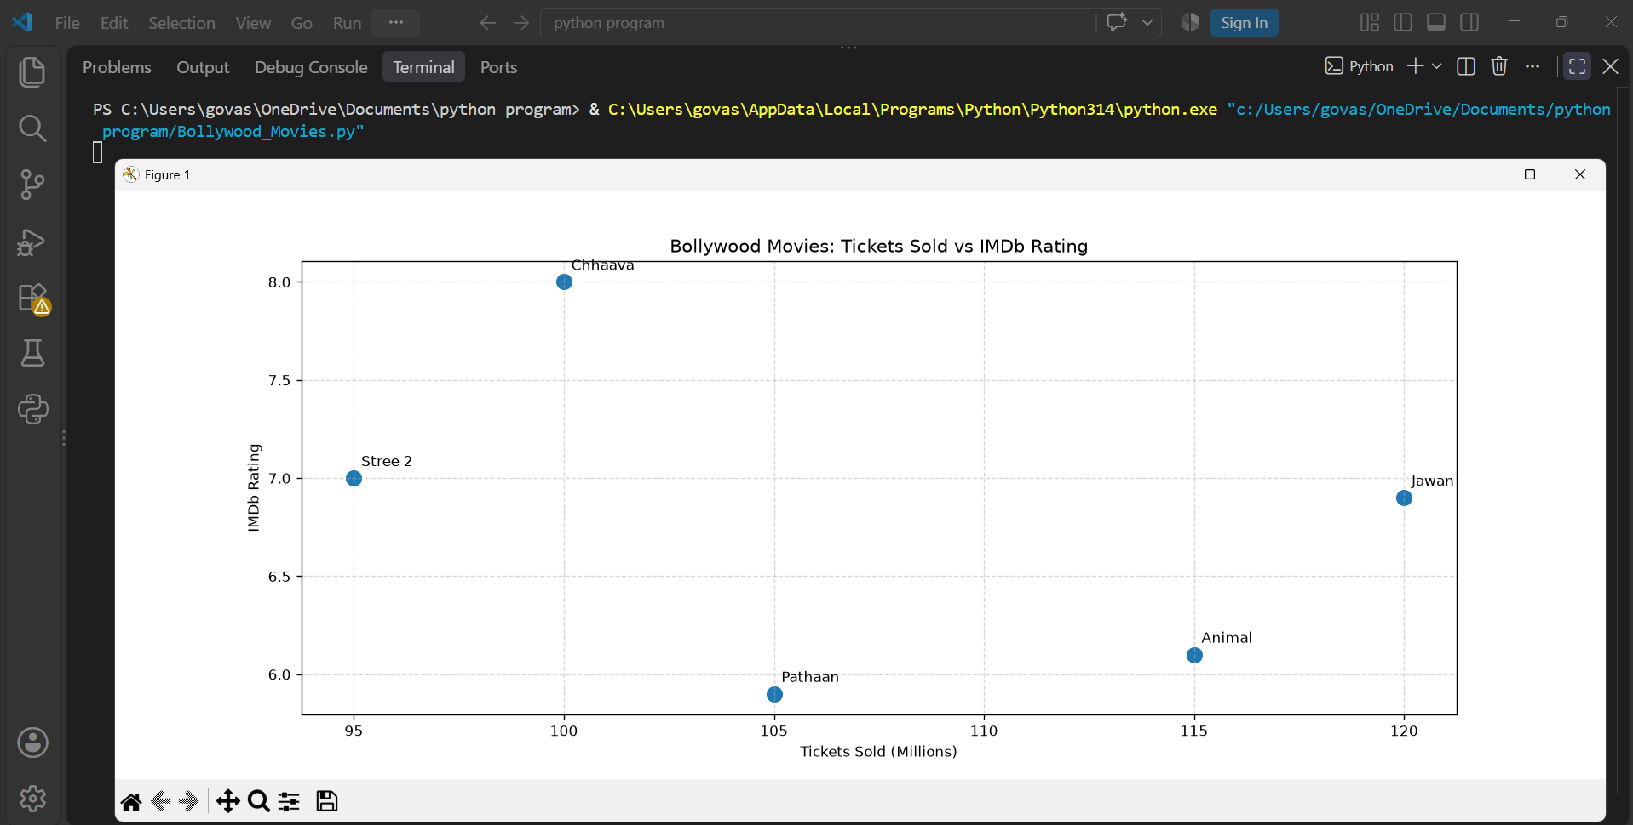
plt.show()
Question : 5
Add a custom text annotation to a Matplotlib chart showing Flipkart's monthly sales, marking the highest sales point with the label 'Big Billion Days'.<br><br><em><strong>Hint:</strong> Use the ax.annotate() function to place the label at the correct data point : </em>

import matplotlib.pyplot as plt
months =[
"Jan","Feb","Mar","Apr","May","Jun",
"Jul","Aug","Sep","Oct","Nov","Dec"]
sales = [
120,135,128,145,150,160,
155,170,180,175,250,190]
plt.figure(figsize=(10, 6))
plt.plot(months,sales,marker="o",linewidth=2)

# Find highest sales point
max_sales =max(sales)
max_index =sales.index(max_sales)

# Add annotation
plt.annotate(
"Big Billion Days",
xy=(months[max_index], max_sales),
xytext=(months[max_index], max_sales + 25),
arrowprops=dict(arrowstyle="->"),
fontsize=12)
plt.title("Flipkart Monthly Sales")
plt.xlabel("Month")
plt.ylabel("Sales (₹ Crores)")
plt.grid(True, linestyle="--", alpha=0.5)
plt.show()
